ShopNest Power BI Dashboard Report

Introduction:
ShopNest stands as the leading department store in the e-commerce marketplaces in Portugal. Serving as a seamless link, it connects small businesses from various regions in Portugal to channels, streamlining the process with a single point of contact. Through the ShopNest Store, these merchants can showcase and sell their products, with the added convenience of direct shipment to customers facilitated by ShopNest logistics partners. The provided data represents authentic commercial information that has undergone the process of anonymization.

1. Identify the rating distribution in the Shop_Nest dataset, showcasing ratings categorized as Excellent, Very Good, Good, Bad, and Very Bad, along with corresponding orders.

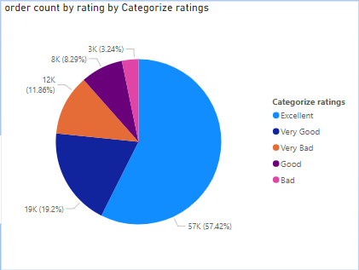

- The highest category of ratings is "Excellent," with 57K orders, representing 57.42% of the total.
- The "Very Good" category follows, with 19K orders, accounting for 19.2% of the total.
- The "Good" category has 12K orders, making up 11.86% of the total.
- The least represented categories are "Very Bad" with 8K orders (8.29%) and "Bad" with 3K orders (3.24%).
2. What are the top 10 and bottom 18 most popular product categories in the ShopNest dataset?
i) Top 10 popular product categories:
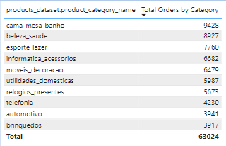

ii) Bottom 18 popular product categories:
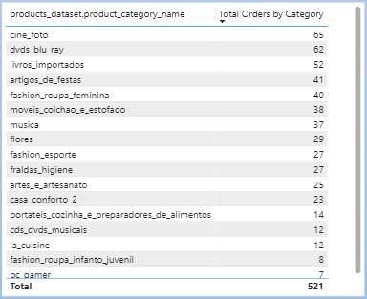

- The top 10 most popular product categories in the ShopNest dataset are led by "cama_mesa_banho" with 9,428 total orders, followed by "beleza_saude" (8,927) and "esporte_lazer" (7,760). Other categories include "informatica_acessorios" (6,682) and "moveis_decoracao" (6,479).
- The remaining top 10 include "utilidades_domesticas" (5,987), "relogios_presentes" (5,673), "telefonia" (4,230), "automotivo" (3,941), and "brinquedos" (3,917), with a total order count of 63,024 across these categories.
- The bottom 18 most popular product categories start with "cine_foto" at 65 orders, followed by "dvds_blu_ray" (62), and "livros_importados" (52). Other categories include "artigos_de_festas" (41), "fashion_roupa_feminina" (40), and "moveis_colchao_e_estofado" (38).
- The lowest three categories are "cds_dvds_musicais" (12), "la_cuisine" (12), and "fashion_roupa_infanto_juvenil" (8), with "pc_gamer" at the bottom with only 7 orders. The total count for these bottom 18 categories is 521.

3. Which payment methods are most commonly used by ShopNest customers.

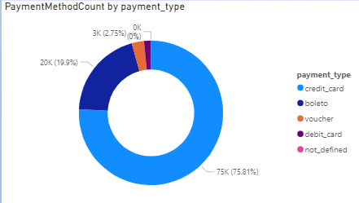

- The most commonly used payment method by ShopNest customers is "credit_card," with 75K transactions, making up 75.81% of the total.
- The second most common payment method is "boleto," which accounts for 20K transactions or 19.9% of the total.
- "Voucher" is used for 3K transactions, representing 2.75% of the total.
- "Debit_card" and "not_defined" are rarely used, contributing 0K transactions, indicating minimal or no usage.

4. Identify the product category. wise profit margin using the formula.

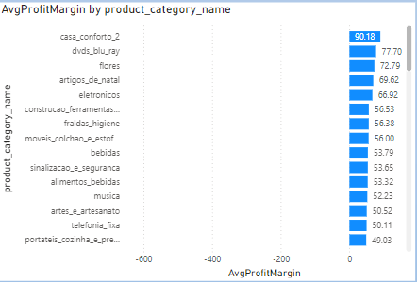

- Highest Profit Margin: The product category with the highest average profit margin is "casa_conforto_2" with a margin of 90.18.
- Other High Performers: Categories like "dvds_blu_ray" (77.70), "flores" (72.79), and "artigos_de_natal" (69.62) also have significantly high average profit margins.
- Moderate Profit Margins: Categories such as "moveis_colchao_e_estofados" (56.00), "bebidas" (53.79), and "musica" (52.23) show moderate profit margins.
- Negative Profit Margins: It appears that some categories (not explicitly labeled in this part of the graph) have negative average profit margins extending up to -600, indicating potential losses in those segments.

5. Identify sellers categorized by city, excluding cities starting with the letters S and B.

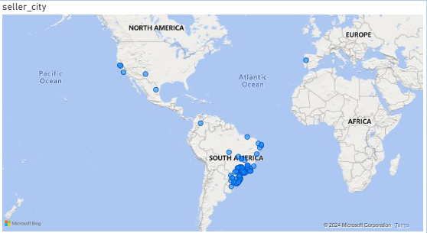

- Geographical Distribution: The majority of sellers are located in South America, with a notable concentration in Brazil.
- Presence in Other Regions: There are a few seller cities scattered across North America and Europe, indicating a limited international presence outside South America.
- Exclusion Criteria: Cities starting with "S" and "B" have been excluded, which may exclude prominent cities like São Paulo, Salvador, and Brasília from the analysis.
- Observation on Clustering: The clustering in South America suggests the primary market and seller activity focus is in this region, aligning with the dataset's likely origin or focus area.

6. ⁠Create a dynamic visual that compares the number of delayed orders to the number of orders received earlier for each month. Utilize the drill through the cross-report feature to provide a detailed analysis of late and on-time deliveries.

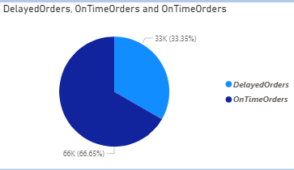

- Overall Distribution: The chart indicates that 33% of orders (33K) are delayed, while 67% of orders (66K) are delivered on time.
- Performance Observation: A majority of orders are delivered on time, suggesting a relatively efficient delivery process, but the 33% delayed orders highlight room for improvement.
- Actionable Insight: Using the drill-through feature, further analysis can identify specific months, regions, or product categories contributing to delays.
- Focus Area: Detailed analysis of the delayed orders can help pinpoint root causes such as logistical bottlenecks, seasonal demand spikes, or specific vendor performance issues.

